select ename ||' '|| hiredate AS empHiredate from emp;

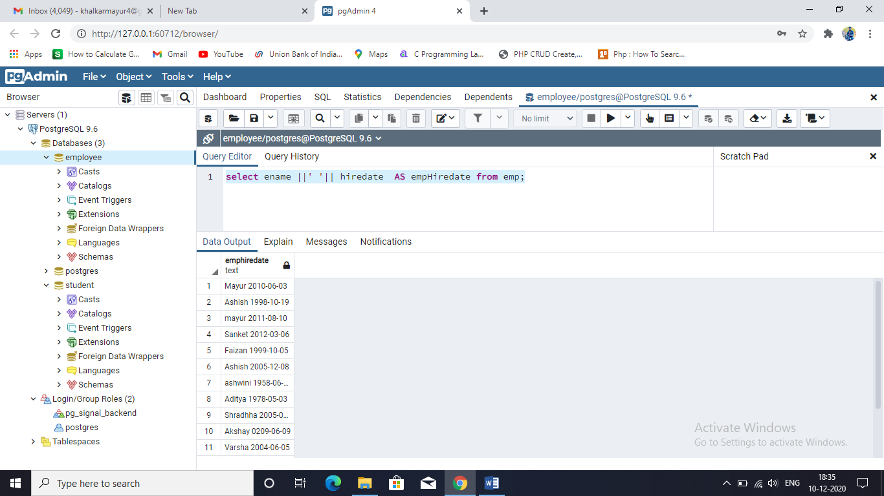

**JOIN OPERATION ON FOLLOWING TABLE**

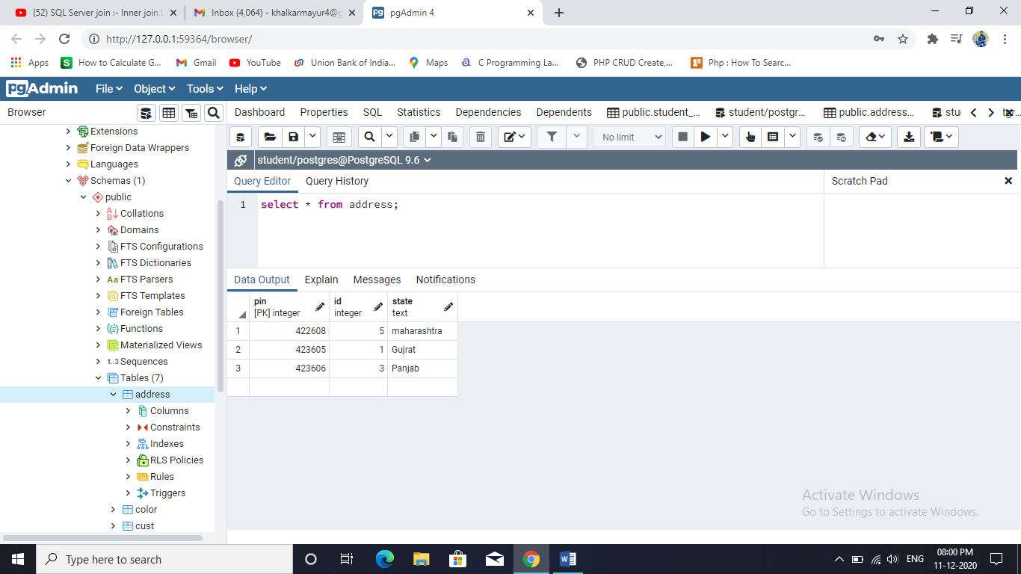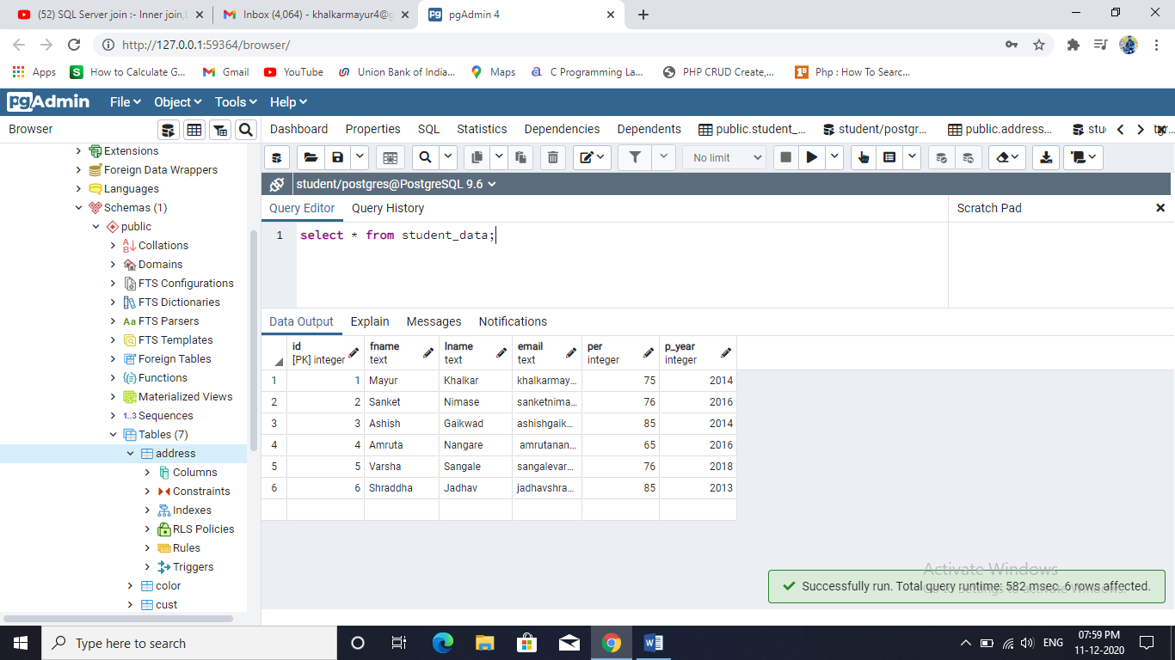**Student_data address**

**INNER JOIN**

select * from student_data inner join address on student_data.id = address.id;

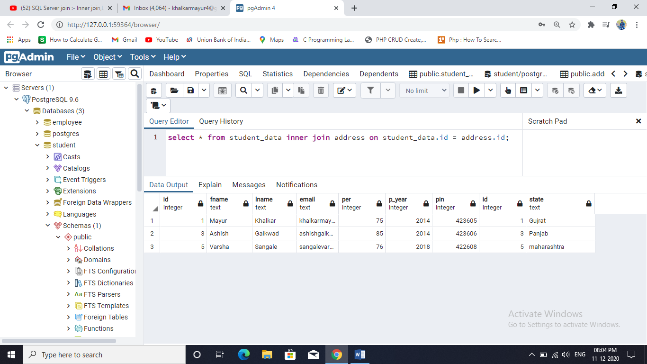

**Left Join**

select * from student_data left join address on student_data.id = address.id;

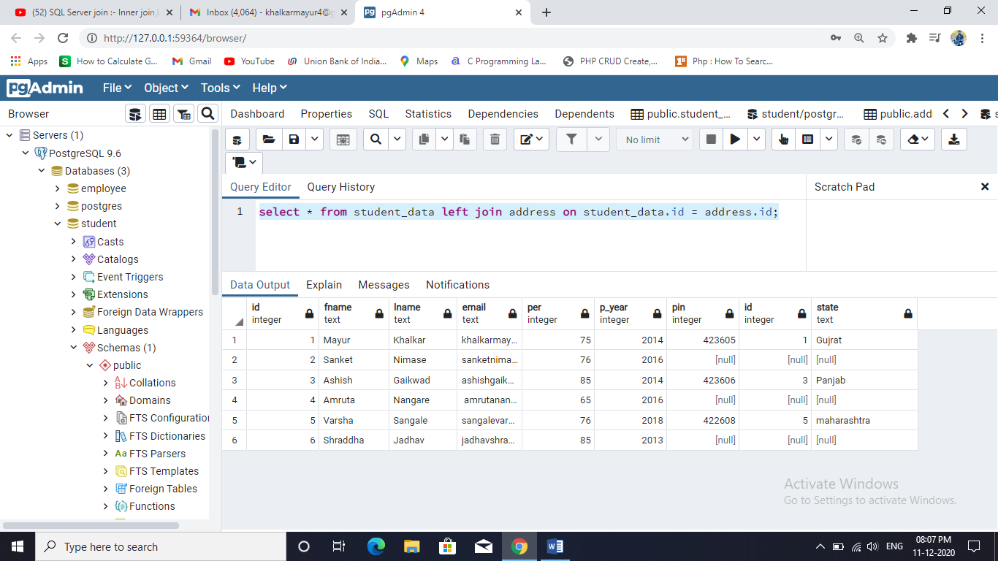

**Right Join**

select * from student_data right join address on student_data.id = address.id;

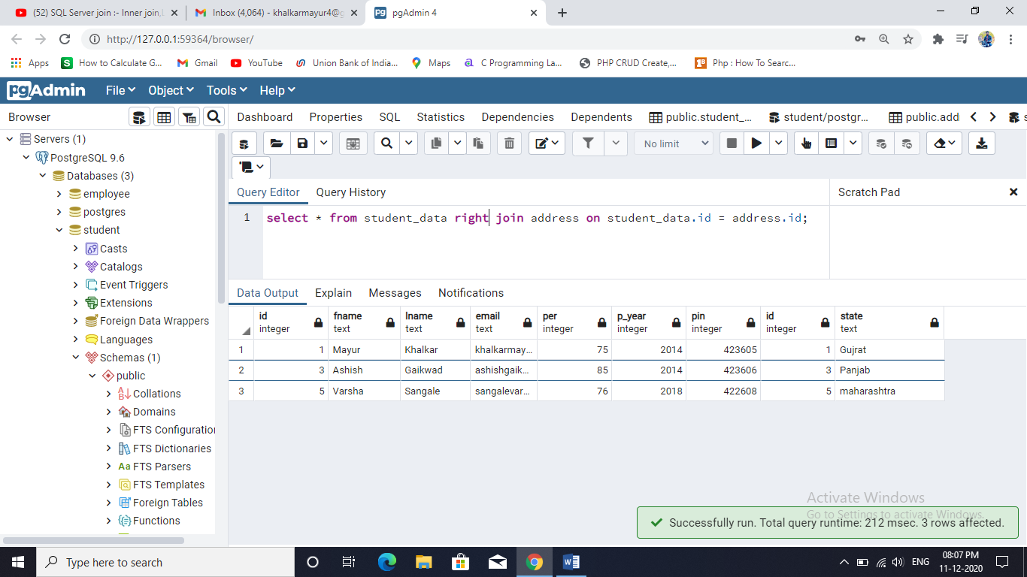

**FULL OUTER JOIN**  
select * from student_data full outer join address on student_data.id = address.id;

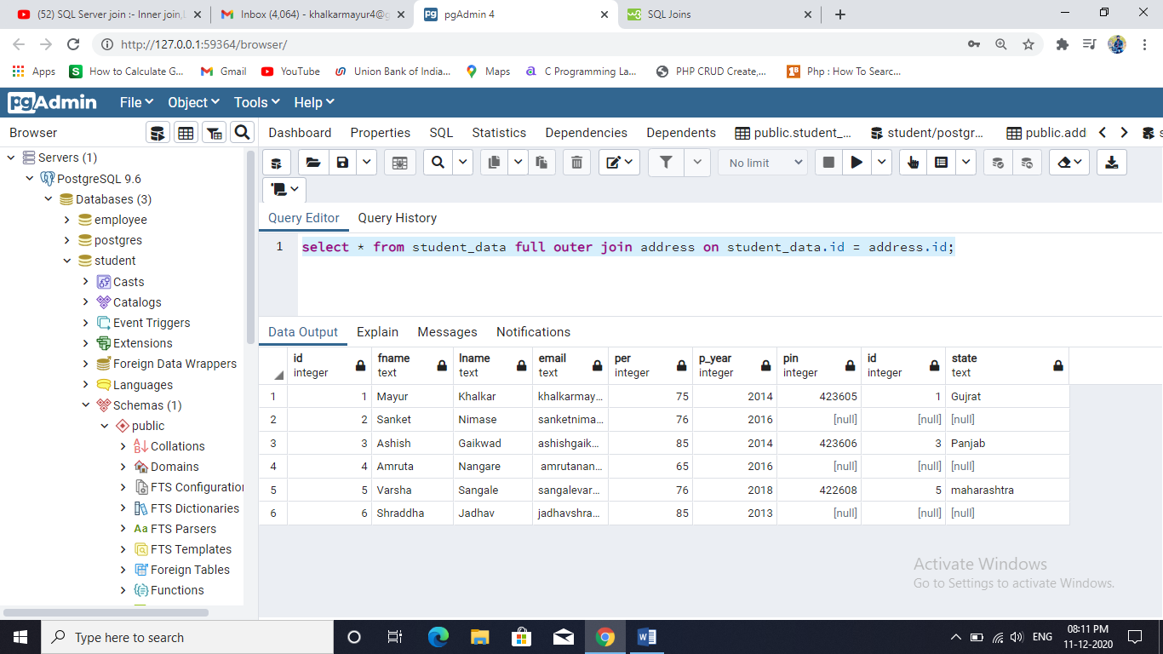

**FULL JOIN**

select * from student_data full join address on student_data.id = address.id;

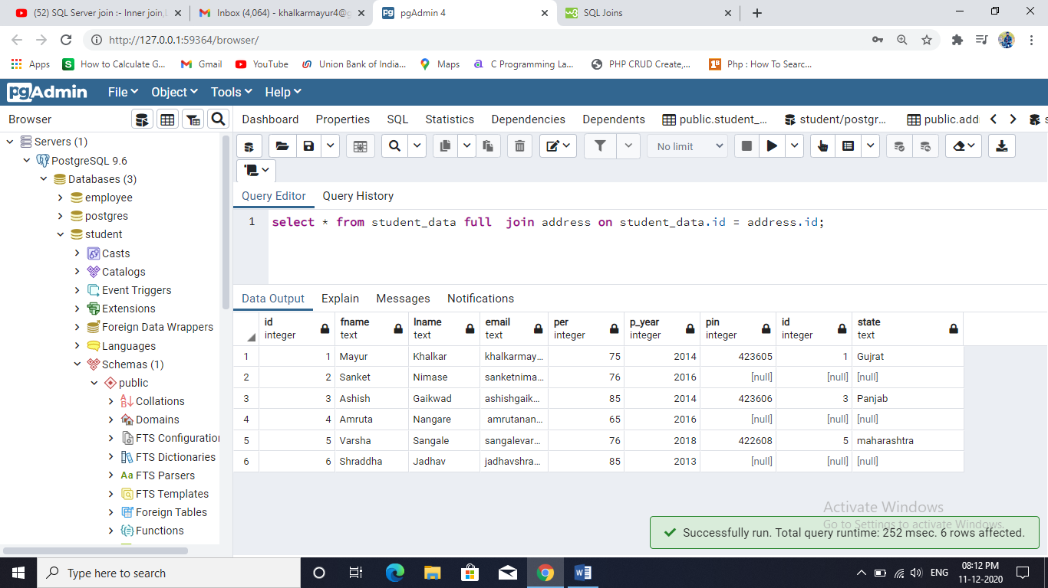

**Cross JOIN**

select * from student_data,address;

or

select * from student_data cross join address;

